QUERY 1:
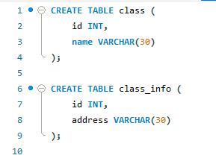
OUTPUT:

QUERY 2:
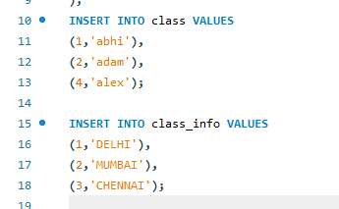
OUTPUT:

QUERY 3:
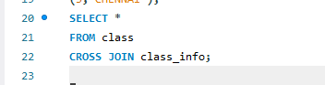
OUTPUT:

QUERY 4:
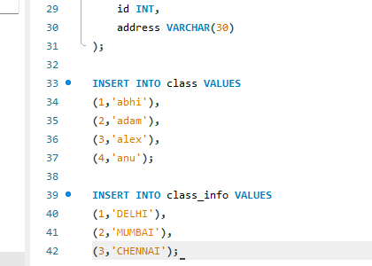
OUTPUT:

QUERY 5:
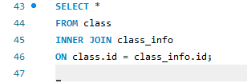
OUTPUT:

QUERY 6:
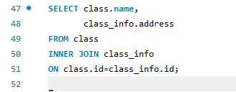
OUTPUT:

QUERY 7:
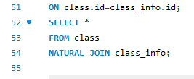
OUTPUT:

QUERY 8:
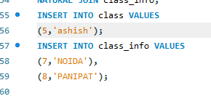
OUTPUT:

QUERY 9:
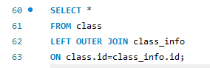
OUTPUT:

QUERY 10:
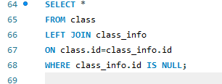
OUTPUT:

QUERY 11:
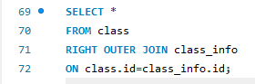
OUTPUT:

QUERY 12:
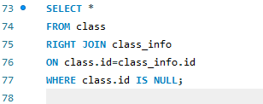
OUTPUT:

QUERY 13:
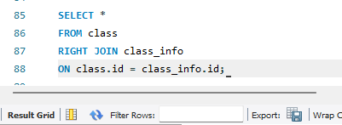
OUTPUT:

QUERY 14:
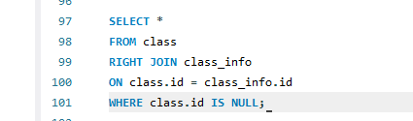
OUTPUT:

QUERY 15:
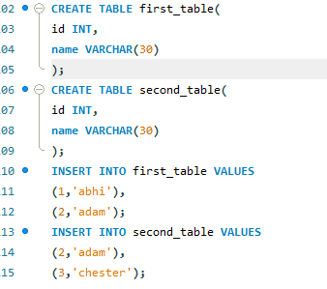
OUTPUT:

QUERY 16:
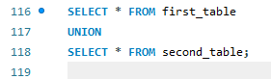
OUTPUT:

QUERY 17:
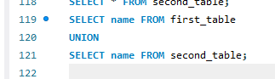
OUTPUT:

QUERY 18:
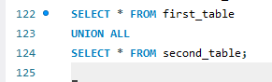
OUTPUT:

QUERY 19:
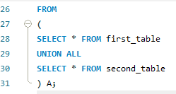
OUTPUT:

QUERY 20:
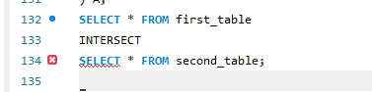
OUTPUT:

QUERY 21:
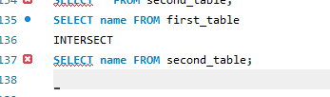
OUTPUT:

QUERY 22:
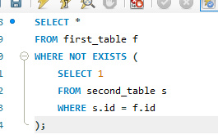
OUTPUT:

QUERY 23:
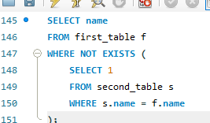
OUTPUT:

QUERY 24:
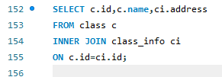
OUTPUT:

QUERY 25:
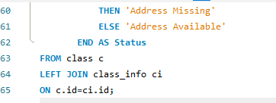
OUTPUT:

